FSR Small reef associated leatherjacket, batfish, goatfish, grenadier (Macrouridae are deepwater demersal, continental slope) , gurnards, nannygai, old wife, pigfish

**Batfishes:**

Roundface Batfish, Platax teira

Longfin Batfish, Platax pinnatus

herbivores, feed on macroalgae,

*Platax orbicularis:* Of eight major prey items identified, algae showed the dominant values for frequency, and volumetric and importance indexes in daylight samples (AIi = 5535); whereas zooplankton of the order Myscidacea were dominant for night-time samples (AIi = 5625; Table 1). The frequency of occurrence of algae in night time samples was 80%, indicating that most individuals experienced the food switch.

David R. Bellwood, Terry P. Hughes, and Andrew S. Hoey 2006 Sleeping Functional Group Drives Coral-Reef Recovery. Current Biology 16, 2434–2439.

Breno Barros Æ Yoichi Sakai Æ Hiroaki Hashimoto Æ Kenji Gushima. 2008. Feeding behavior of leaf-like juveniles of the round batfish Platax orbicularis (Ephippidae) on reefs of Kuchierabu-jima Island, southern Japan. 26:287–293

**leatherjackets (Monacanthidae):**

*Nelusetta ayraudi* Horseshoe leatherjacket *Meuschenia hippocrepis,* Sixspine leatherjacket *Meuschenia freycineti*

Herbivorous they fed on a variety of red and green turfing algae. Several omnivorous leatherjackets (Monacanthidae) regularly observed to consume algae, including Penicipelta vittiger (Castelnau), Meuschenia hippocrepis (Quoy & Gaimard), M.flavolineata (Hutchins), M.freycineti (Quoy & Gaimard), Eubalichthys gunni (Gunther). Most of these fed on the mixed red/green algal turf associated with the substratum.

The diet of **N.** *ayraudi* consisted of fish (23. 1%), salps (1 9,0%), gastropods (1 3,50/o),

crustaceans (12.7%) and algae (0.3%).

*Monacanthus chinensis* consumed the largest amount (40%) and greatest variety of animal foods, and *Meuschenia trachylepis* took the smallest quantity (12%) and number of animal foods and the greatest amount (55 %) of algae. All three species were found to be highly dependent on the encrusting fauna, epiphytic algae and other epifauna and infauna of this seagrass habitat. All three species were omnivorous, consuming considerable amounts of seagrass and algae as well as animal material. However, only the encrusting fauna and epiphytic algae of the seagrass appeared to be actually digested.

Monacanthus chinensis and Meuschenia trachylepis were omnivorous, with algae as a major and seagrass as a minor food item. Last (1975) studied the diets of Meuschenia australis, Meuschenia freycineti, Penicipelta vittiger and Acanthaluteres spilomelanurus and found that they all consumed algae, the first two species taking more than the others; however, he concluded that plant material was taken incidentally in the pursuit of amphipods.

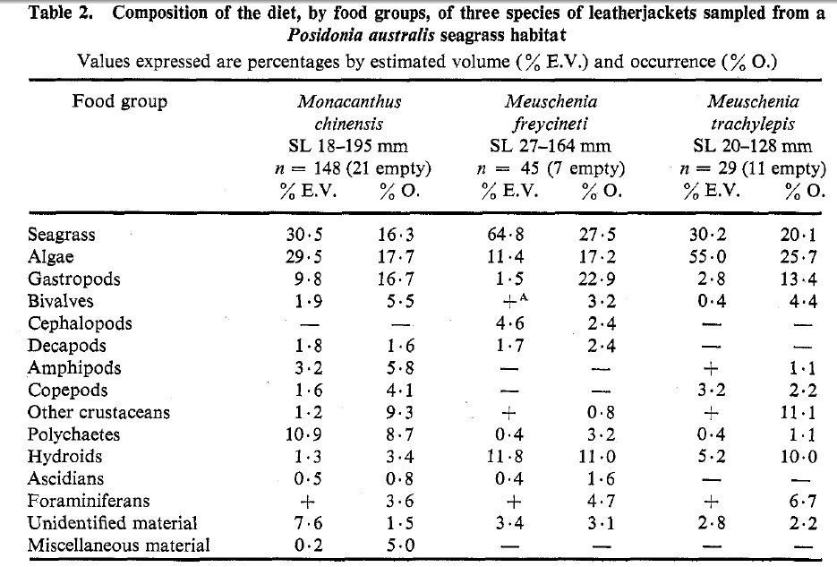

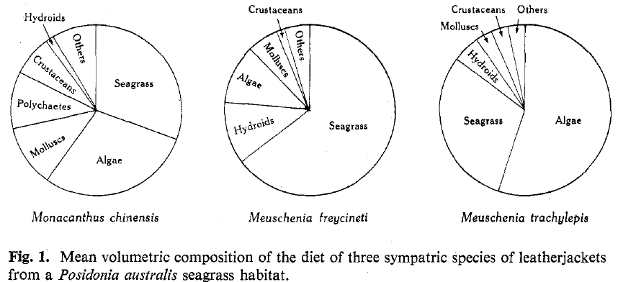

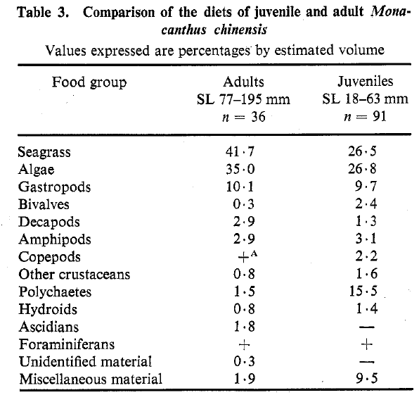

*Gastropods*

*Monacantlzus chinensis* consumed the greatest variety, including unidentified

species from the genera *Alaba, Bedeua, Bittium, Cl~emnitzia, Linopyrga, Nassarius,*

*Smaragdista* and *Zafra* and the families Atyidae, Retusidae and Vitrinellidae. Juvenile

Aplysiidae and gastropod egg masses were also found in this species. *Meuschenia*

*trachylepis* consumed the same range of species as *Monacanthus chinensis* with the exception of the families Atyidae, Retusiidae and Aplysiidae. *Alaba, Bittium, Chemnitzia,* juvenile *'Gibbula',* juvenile Aplysiidae and gastropod egg masses were consumed by *Meuschenia freycineti.*

*Bivalves*

In Monacanthus chinensis this category consisted of Anadara trapezium, Hiatella

australis and unidentified species of the genera Kellia, 'Musculus' and Monia. Anadara trapezium and unidentified valve fragments were present in Meuschenia freycineti.

This category was also fairly limited in Meuschenia trachylepis with only Hiatella

australis and Chlamys being present.

*Cephalopods*

This category was present only in Meuschenia freycineti and was made up of unidentified juvenile cephalopods, probably taken from a hatching egg mass.

*Decapods*

In Monacanthus chinensis this category consisted of the crab Nectocarcinus, the shrimps Penaeus, Alpheus and Macrobrachium and other unidentified shrimp and crab species. Alpheid shrimps and unidentified crabs were found in Meuschenia

freycineti. No decapods were present in M. trachylepis.

*Amphipods*

This category consisted of the genera Cymadusa, Amphithoe and Liljeborgia in

Monacanthus chinensis and only unidentified species in Meuschenia trachylepis. No amphipods were found in Meuchenia freycineti.

*Copepods*

In both Monacanthus chinensis and Meuschenia trachylepis this category comprised several species including Temora turbinata, Paracalanus and an unidentified cyclopoid species. Copepods were absent from the diet of Meuschenia freycineti.

*Other crustaceans*

This category consisted of barnacles (Balanus), cumaceans (family Diastylidae), the ostracod Loxoconcha australis and unidentified tanaidaceans. Monacanthus chinensis consumed all of these crustaceans, Meuschenia trachylepis consumed all but the cumaceans, and Meuschenia freycineti consumed only Loxocoizcl?a australis.

*Polychaetes*

In all three fish species this category consisted of unidentified sedentary

polychaetes of the families Spionidae and Capitellidae

*Hydroids*

Unidentified hydroids were present in all three fish species, being frequently attached to pieces of seagrass.

*Ascidians*

In all three fish species this category consisted of Styela and other unidentified ascidians.

*Foraminiferans*

In all three fish species only a single species, Elphidium craticulatum, was found.

*Miscellaneous material*

Small numbers of chironomid larvae, unidentified trematodes, an unidentified teleost and sand grains were found in Monacanthus chinensis.

*Meuschenia freycineti* has stronger, more robust jaw teeth than the other two species and is thus better adapted to biting off pieces of seagrass. A total of 94% of the diet of this species is made up of encrusting organisms, including bryozoans, spirorbids, algae, hydroids, and mollusc egg masses. *Meuschenia trachylepis,* on the other hand, has weaker mouth parts which would be better suited to selecting algae, although a significant amount of seagrass is also taken.

References:

Rolf Lindholm 1984.Observations on the Chinaman Leatherjacket *Nelusetta ayraudi* (Quoy & Gaimard) in the Great Australian Bight. Aust. J. Mar. Freshw. Res. 35, 597-599

Bell, J. D., Burchmore, J. J., and Pollard, D. A. (1978). Feeding ecology of three sympatric species of leatherjackets (Pisces : Monacanthidae) from a *Posidonia* seagrass habitat in New South Wales. *Aust. J. Mar. Freshw. Res.* 29, 631-43.

**goatfish** Upeneus australiae Bartail Goatfish, Upeneus tragula, Bluespotted Goatfish, Upeneichthys vlamingii, Bluestriped Goatfish, Upeneichthys lineatus, Blacksaddle Goatfish, Parupeneus spilurus

Latchet Gurnard, Pterygotrigla polyommata, Spiny Gurnard, Lepidotrigla papilio, Red Gurnard, Chelidonichthys kumu

The 18 and 23 dietary categories identified for *U. stotti* and *U. lineatus*, respectively, consisted predominantly of crustaceans, being found in the guts of 97·1 and 87·1% of these two species, respectively. Crustaceans made the highest contribution to the total numbers (91·4 and 77·6%) and volumes (80·0 and 65·5%) of *U. stotti* and *U. lineatus*, respectively. The next most commonly ingested major taxon was the Polychaeta, occurring in 32·9 and 34·3% of *U. stotti* and *U. lineatus*, respectively, followed by the Mollusca with 2·9 and 24·6%, respectively. Echinoderms were found only in the guts of *U. lineatus*. Teleosts made only a small contribution to the diets of both spirits. Sediment was present in 80·0 and 50·8% of the guts of *U. stotti* and *U. lineatus*, respectively. In *U. stotti*, tanaids (54·3%), gammarid amphipods (45·7%), cumaceans (37·1%) and mysids (30·0%) were the most frequent dietary categories, with the first two contributing 26·2 and 19·9%, respectively, by numbers (Table II). Cumaceans, tanaids and mysids contributed between 12·6 and 14·4% to the overall dietary volume, polychaetes other than pectinariids and onuphids 6·7%, while bivalve and cephalopod molluscs collectively contributed <1%. In *U. lineatus*, gammarid amphipods, tanaids and brachyuran crabs were each ingested by >25% of fish. Tanaids contributed 37·6% by numbers, while the other categories contributed no more than 13·4% each. By volume, brachyuran crabs and tanaids contributed 11·0 and 9·2%, respectively, while gammarid amphipods contributed 8·0%, flabelliferan isopods 6·8% and mysids 5·6%. Bivalve molluscs also made a substantial contribution (8·8%) to the dietary volume. Pectinariid and onuphid polychaetes each made greater contributions to the dietary volume (3·9 and 3·4%, respectively) than all other polychaetes combined (Table II).

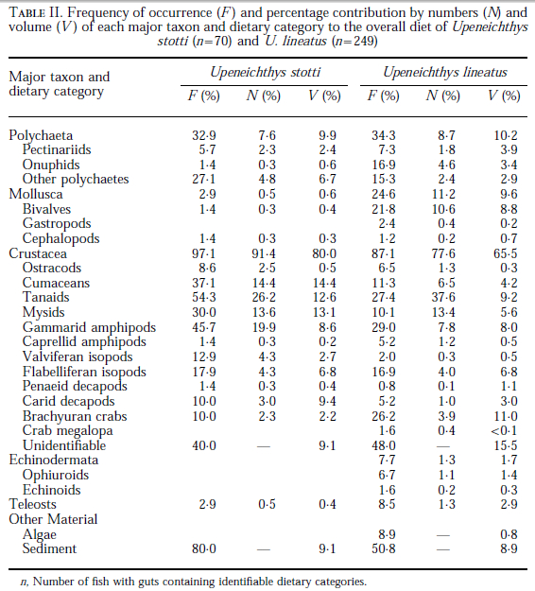

In the smallest *U. stotti* (80–99 mm), mysids, tanaids and polychaetes contributed collectively nearly 80% of the total dietary volume, while cumaceans, amphipods and crabs each contributed between 3 and 5% (Fig. 4). As *U. stotti* increased in length, the mysids and tanaids contributed less to the diet, whereas carid decapods and isopods contributed more. Cumaceans made their greatest contribution in the 120–139-mm length class. The largest fish ate mainly carid decapods, isopods, mysids, amphipods and polychaetes (Fig. 4). In the smallest *U. lineatus* (60–79 mm), mysids contributed over 75% to the volume of the gut contents, with small volumes of polychaetes and sediment also being ingested (Fig. 4). In the 80–99-mm length class, the contribution of mysids declined sharply (32%), while amphipods made up nearly 20%. Other dietary categories included bivalves, cephalopods, isopods, carid decapods, crabs, echinoderms, fish and algae. In fish of 100–119 mm, the contributions of amphipods and crabs increased, and tanaids contributed *c.* 7%. Most fish >120 mm, ate mainly polychaetes, bivalves, tanaids, mysids, amphipods, isopods and crabs, with the largest fish consuming mainly crabs and mysids (Fig. 4).

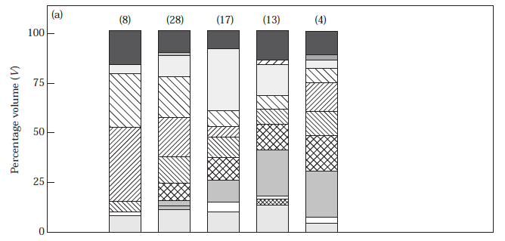

In the coastal waters of the inner shelf of south-western Australia, *U. stotti* and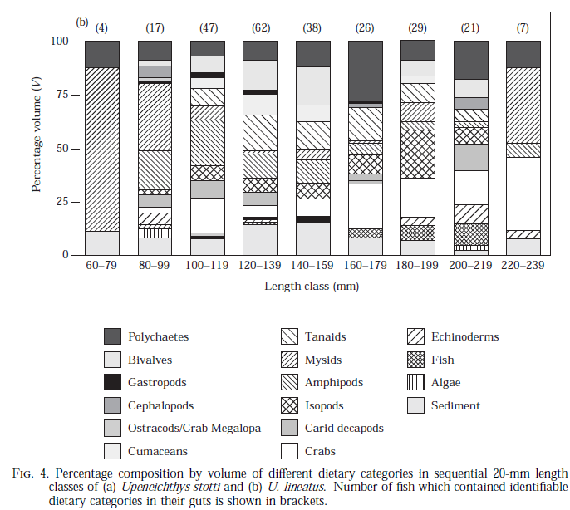

*U. lineatus* both fed on a variety of benthic and epibenthic invertebrates, and particularly crustaceans, with polychaetes and molluscs making a lesser contribution, similar to most other mullids . Ontogenetically, *U. stotti* and *U. lineatus* show a sequential decrease in small prey (mysid, tanaid and amphipod crustaceans), and a progressive increase in larger prey (carid decapods in *U. stotti* and brachyuran crabs in *U. lineatus*).

*Lepidotrigla modesta* and *Lepidotrigla papilio* The contributions of crustaceans to the diets of each species ranged from 92·1 to 97·6% for total numbers of prey and from 72·4 to 95·0% with dietary volume. Molluscs made only a small contribution to the diets of each species, with the greatest contribution to the dietary volume, i.e. 4·6% and the contribution of algae to the dietary volume of each species was always <0·1%. Mysids and cumaceans were by far the most important dietary categories of *L. modesta*, contributing 42·5 and 26·7%, respectively, to the total numbers, and 25·4 and 32·1%, respectively, to the dietary volume of this species. The only other dietary categories that contributed more than 5% to the total numbers of *L. modesta* were gammarid amphipods and carid decapods, which also made substantial contributions to the dietary volume, i.e. 14·9 and 13·0%, respectively. Although mysids and cumaceans were also the most important dietary categories in terms of both numbers and volume in the stomach contents of *L. papilio*, their contributions to the dietary volume of this species, i.e. 20·0 and 18·5%, respectively, were less than for *L. modesta.* Flabelliferan isopods, carid decapods, gammarid amphipods and oxyrhyncan crabs contributed 16·2, 11·4, 10·0 and 8·8%, respectively, to the dietary volume of *L. modesta*. In terms of volume, the diets of the smaller individuals of *L. modesta*, i.e. 75–99 mm, comprised mainly cumaceans

(36·3%), amphipods (20·8%) and mysids (16·8%), with carid decapods contributing a further 8·0%. These same dietary categories were also the most important in the diets of the next two larger size classes. However, in the case of the largest fish, the diets were dominated by isopods and amphipods, which collectively contributed nearly 70% to the overall dietary volume. In the case of *L. papilio*, nearly 40% of the dietary volume of the smallest size class, i.e. 75–99 mm, comprised mysids, whereas ostracods, cumaceans, amphipods and isopods contributed between 9 and 19%. As this triglid increased in size, the dietary contributions of ostracods and mysids declined progressively until these prey were virtually absent in the diets of the largest fish, i.e. 150– 174 mm. In contrast, the contributions of cumaceans and isopods increased with body size, with the result that they collectively contributed nearly 75% of the diets of the largest fish. Carid decapods and crabs made substantial contributions only to the diets of fish of 100–149 mm.

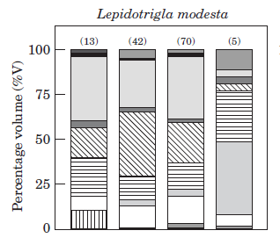



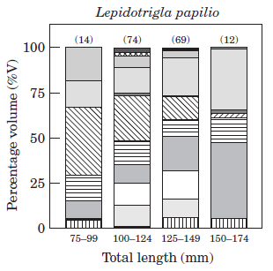

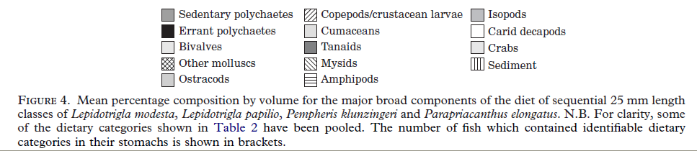

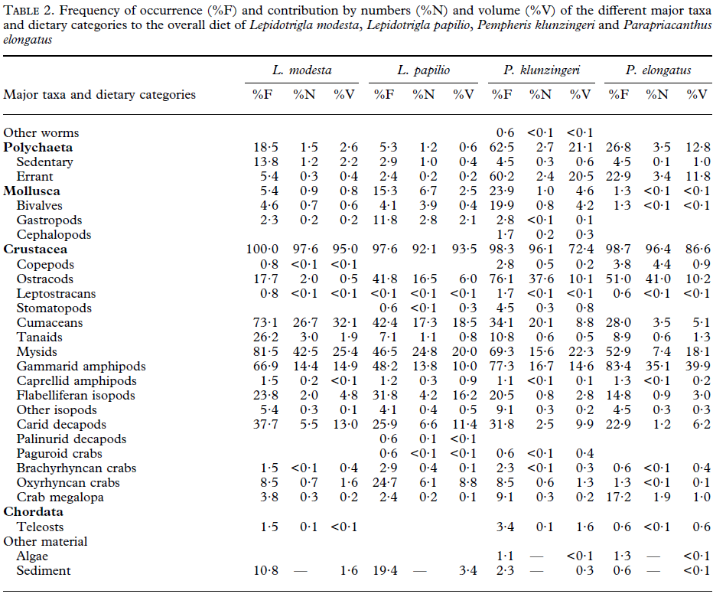

References:

Platell, M.E., Potter, I.C, and Clarke, K.R. 1998. Do the habitats, mouth morphology and diets of the mullids *Upeneichthys stotti* and *U. lineatus* in coastal waters of south-western Australia differ? *Journal of Fish Biology* (1998) 52, 398–418.

M. E. Platelland I. C. Potter. 1999. Partitioning of Habitat and Prey by Abundant and

Similar-sized Species of the Triglidae and Pempherididae (Teleostei) in coastal waters. *Estuarine, Coastal and Shelf Science* 48, 235–252

**Nannygai:**

Redfish, Centroberyx affinis It feeds on zooplankton in the midwaters. Feed on small fish, crustaceans and mollusks

Bight Redfish, *Centroberyx gerrardi*

*Centroberyx lineatus*

Redfish are bentho-pelagic feeders, mainly feeding on bentho-pelagic fish and pelagic crustaceans

Coleman and Mobley, 1984, and Bulman et al., 2001, cited by Bruce et al., 2002

There is little information on the diet, but small bony fishes (such as pilchards) are part of the diet of *C. lineatus* (Masuda and Allen, cited in Froese and Pauly, 2009; Caines, 2005).

http://www.fishbase.org/summary/14129

**Old Wife:**

Enoplosus armatus The species is carnivorous, eating primarily crustaceans and worms.

**Pigfish**

Western Pigfish, *Bodianus vulpinus* no info

*Bodianus frenchii (Foxfish)* already included

juveniles

|  |  |
| --- | --- |
| **prey item** | **probability of consuming** |
| MA | 0.3 |
| SGR | 0.3 |
| BG | 0.1 |
| BFF | 0.1 |
| BC | 0.2 |
| ZME | 0.1 |
| SAL | 0.05 |
| DL | 0.05 |
| DR | 0.05 |
| BAC | 0.05 |

adults

|  |  |
| --- | --- |
| **prey item** | **probability of consuming** |
| MA | 0.3 |
| SGR | 0.3 |
| BG | 0.1 |
| BFF | 0.1 |
| BC | 0.1 |
| ZME | 0.1 |
| SAL | 0.05 |
| MAZ | 0.1 |
| DL | 0.05 |
| DR | 0.05 |
| BAC | 0.05 |